# *HAMZA EJAZ*

# *S # B19102041*

# *BSCS-III (MORNING)*

# *Section-A*

# *Database Management*

# *System*

# Q1. Create table Customer with Following Constraints.

CREATE TABLE *table_name* ( column1 datatype, column2 datatype, column3 datatype,

....

);

**Input:**

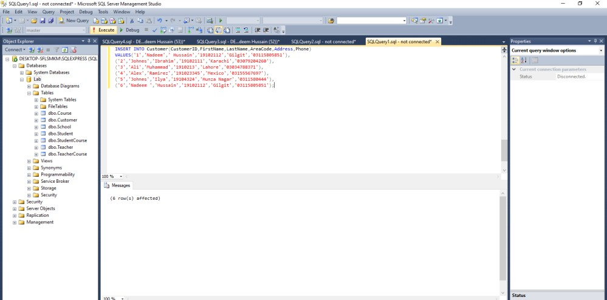

**Output:**

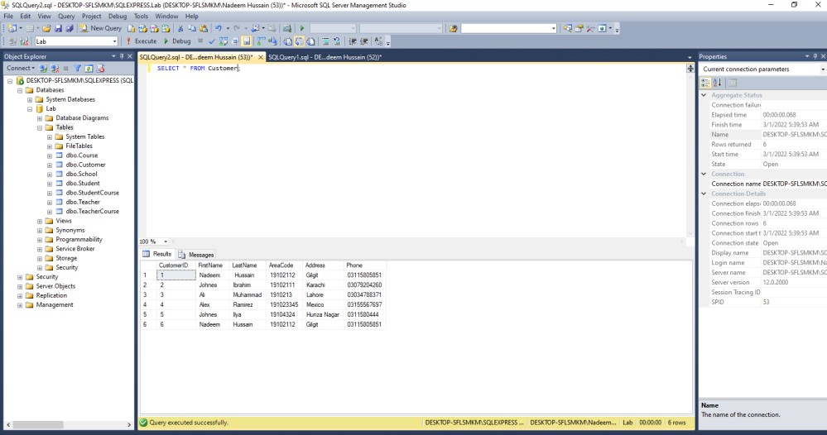

**Q2. Create Tables of: School, Student, Teacher, Course, Grade, Teacher_Course and Student_Course and show the relationship among them.**

**Input of School:**

INSERTINTOSchool(SchoolID,SchoolName,SchoolAddress,PostCode,Phone)VALUES('1','Star Raising Rakaposhi','Gilgit','6000','03115805851'),

('2','Shah Wali Model Academy ','Karachi','4333','03034788371'), ('3','GOVT Boys','Lahore','03033','03079204260'),

('4','Al Noor','Mexico','7697','03155567697'),

('5','The Learning Academy','Hunza Nagar','80444','031158505851'), ('6','Army public','Gilgit','1580','03475566666');

**Output Of School:**

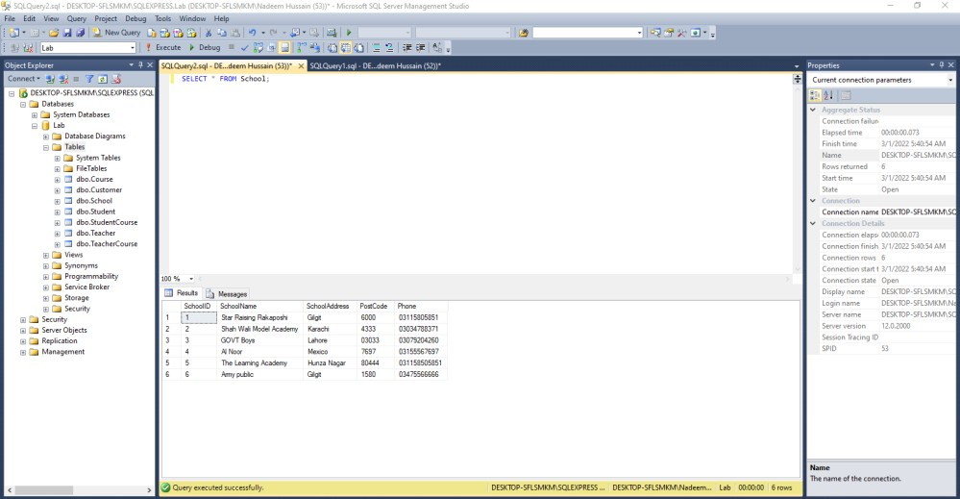

**Input of Student:**

INSERT INTO Student(StudentID,StudentName,StudentNumber,TotalGrade,Address,Phone,Email) VALUES('1','Nadeem Hussain','19102112','A+','Gilgit','03115805851','nadeemnageri@gmail.com'), ('2','Johnes','19102111','A+','Karachi','03079204260','b19102112@gmail.com'),

('3','Ali','1910213','B+','Lahore','03034788371','Ramirez@gmail.com'),

('4','Alex','191023345','c','Mexico','03155567697','nageri@gmail.com'),

('5','Johnes','19104324','A','Hunza Nagar','0311580444','Alinageri@gmail.com'), ('6','Nadeem [Hussain','19102112','A+','Gilgit','03115805851','nadeemnageri@gmail.com'](mailto:Hussain%27%2C%2719102112%27%2C%27A%2B%27%2C%27Gilgit%27%2C%2703115805851%27%2C%27nadeemnageri@gmail.com)); **Output Of Student:**

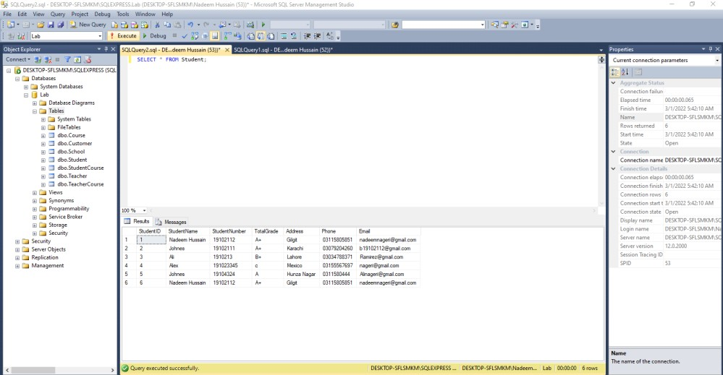

**Input of Teacher:**

INSERT INTO Teacher(TeacherID,TeacherName,TeacherNumber) VALUES('1','FarzeenAshfaq','031111111'),

('2','Badar Sami','0300000000'),

('3','Humera Bashir','0322222222'),

('4','Humera Tariq','0312121221');

**Output of Teacher:**

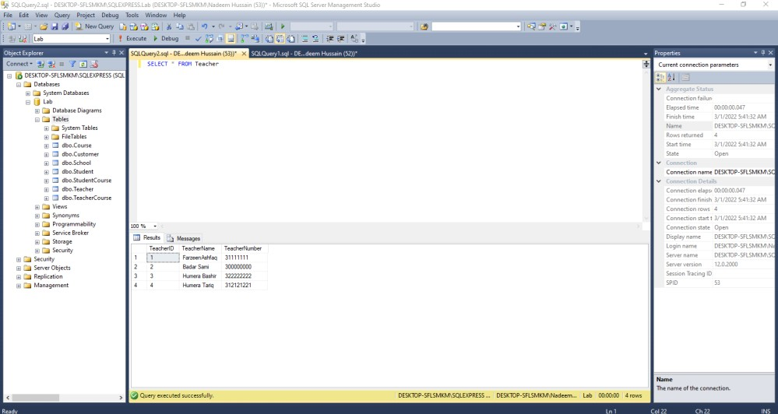

**Input Of Course:**

INSERT INTO Course(CourseID,CourseName,SchoolID,SchoolName) VALUES('1','BSCS','1','Al noor'),

('2','Pharmacy','2','Shah Wali'),

('3','Zology','3','The Learning Academy'),

('4','Electronics','4','Army public'); **Output of Course:**

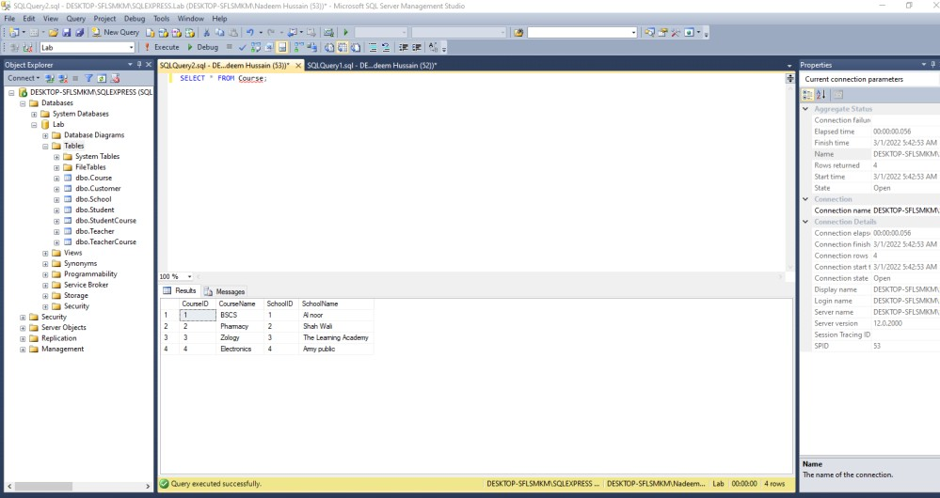

**Input Of Grade:**

INSERT INTO Grade(GradeID,StudentID,CourseID,Grade) VALUES('1','1','1','A'),

('2','2','2','B'),

('3','3','3','C');

**Output of Grade:**

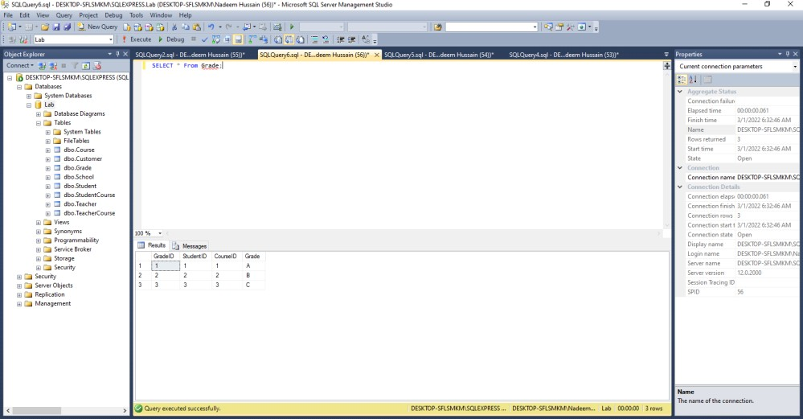

**Input of Student Course:**

INSERT INTO StudentCourse(StudentID,CourseID) VALUES('1','1'),

('2','2'),

('3','3'),

('4','4');

**Output of Student Course:**

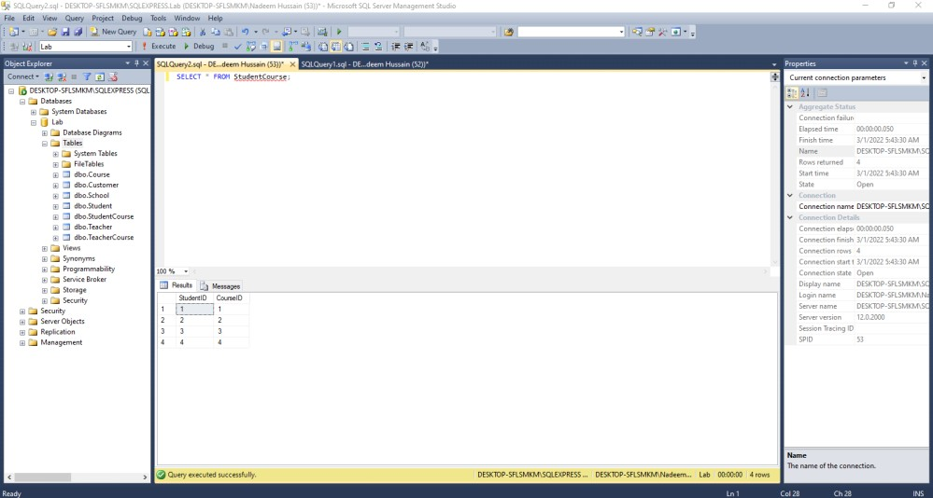

**Input Of Teacher Course:**

INSERT INTO TeacherCourse(TeacherID,CourseID) VALUES('1','1'),

('2','2'),

('3','3'),

('4','4');

**Output Of Teacher Course:**

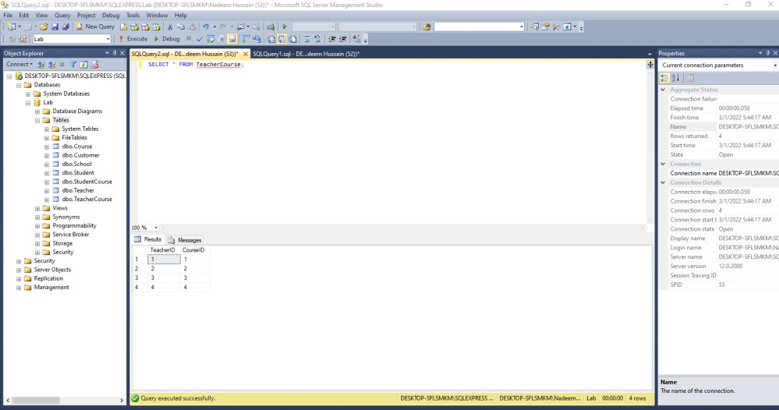

## Q3. INSERT INTO table_name (column1, column2, column3, ...) VALUES (value1, value2, value3, ...);

**Input:**



**Output:**



## Q4.

1. **Write a query to select all students from a table. Output:**

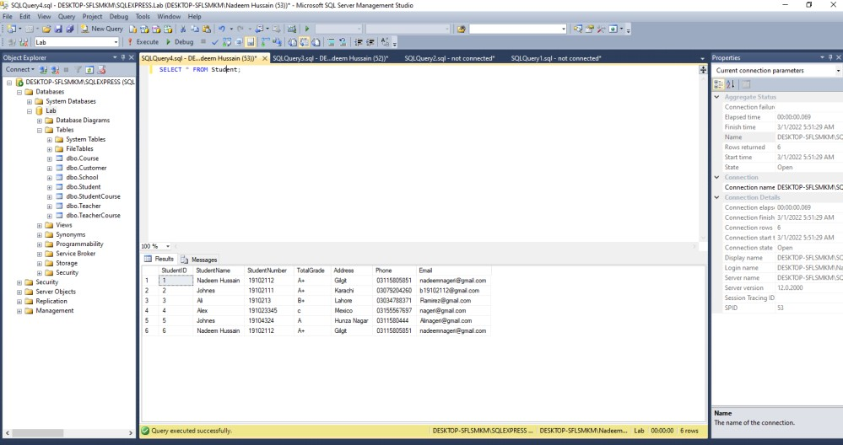

## Select those students whose name is Johnes.

